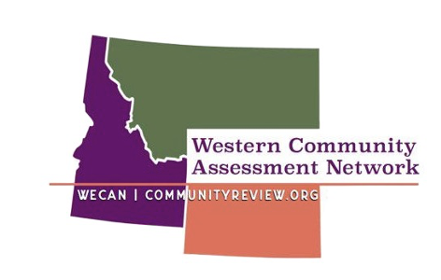

Community Bootcamp 2022
A program of the Western Community Assessment Network

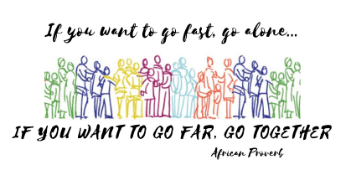

March 23, March 31
April 6, April 13

January 24, 2022

Dear Community Members,

Early in the pandemic, we wondered what we could do together to provide additional help to rural communities. Conversations amongst ourselves, members of the Western Community Assessment (WeCAN)* design team, and WeCAN Peer Learning Network members in Idaho, Montana and Wyoming, led us to conclude that expanding the local leadership base, opportunities to apply leadership skills, building capacity to finance local projects, and collaboration and project implementation skills are most needed in small communities.

From our experiences conducting Community Reviews across the three states we know that improving quality of life, building connections among community members, arts, culture and engaging youth in community building activities are the kinds of things topping resident priority lists. Compared with projects like big infrastructure, many of these can be done with relatively low levels of capital investment and through collaborations among ordinary citizens and service organizations.

The WeCAN Community Bootcamp program will guide communities from project identification to implementation in a series of four virtual workshops in March and April. These 2.5 hour evening sessions (NOTE: the first workshop is three hours) will include a short workshop delivered by experts from around the country, as well as peers from communities in Idaho, Montana and Wyoming sharing experiences with implementing placemaking projects (March 23 only). Each session will also include community breakouts when your team can apply what you just learned to a project in your own community. We will help guide you through the steps each week, provide coaching after the series is over, and match funds you raise, up to $500, to help make your project happen.

If your community participated in the Montana State University program, Reimagining Rural, this is an opportunity for your team to work on project skills and advance a new project or one you are already working on!

If you would like to participate, please complete this simple application by 11:59 pm on February 28th, 2022 and send it to marcimiller@uidaho.edu.

WeCAN Community Bootcamp
DETAILS

BOOTCAMP AGENDA
- Wednesday March 23 – Fostering Rural Innovation. Charlie French with University of New Hampshire Extension will discuss how to promote innovation and investment in rural communities through placemaking activities, and rural community leaders will share short stories of successful projects in their communities. 6:00 – 9:00 pm Mtn. Time (5:00-8:00 Pacific).
- Thursday March 31 – Building a Networks and Telling Stories. Kathleen Minogue, founder of Crowdfund Better and Crowdfund Idaho, will share with you how to create stories that make local organizations and individuals want to invest in your project and how you can identify and build a powerful network of support in your community or region. 6 - 8:30 pm Mtn (5 – 7:30 Pacific).
- Wednesday April 6 – Financing Community Projects. Darin Saul and Soren Newman with University of Idaho’s Grant & Project Development Office will teach you how to develop a funding toolbox that helps you find the money and other resources to make your project a reality. 6 – 8:30 pm Mtn (5 – 7:30 Pacific)
- Wednesday April 13 – Ready, Set, Launch Your Project. Learn about a range of action planning approaches and pick the one that is best for you and your community project. 6 – 8:30 pm Mtn (5 – 7:30 Pacific).
COMMUNITY BENEFITS
- Apply all this learning to a community project that the community team works on together. You’ll leave the bootcamp with a plan for completing your project and inspiration, motivation, team support and ongoing coaching to help that happen.
- Communities that complete the Community Bootcamp are eligible for up to $500 in matching funds to support their selected project. You will also be eligible to apply for a full Community Review and are invited to join WeCAN’s Peer Learning Network.
- Up to $200 to support costs associated with venues and video conference technology if community teams want to gather together for the workshops (we can help you to identify a location if assistance is needed).
APPLICATION REQUIREMENT
In the spirit of welcoming new leaders to the table, think beyond the same ten people that have been getting everything done in your community. The application offers an opportunity to expand your network of doers! Complete and return the application to Marci Miller (marcimiller@uidaho.edu) by February 28, 2022. NOTE: We are selecting only three communities from each state for this opportunity so get your application in ASAP!

Best Regards,
Lorie Higgins, Community Development Specialist & WeCAN Director
University of Idaho Extension
WeCAN Community Bootcamp
APPLICATION

Community: _______________________________________________________________

Individual Completing the Application: __________________________________________

Sponsoring Organization (if applicable): _________________________________________

Mailing Address: ____________________________ City/Zip Code: ______________

Email: ______________________________________ Phone: _____________________

How will participating in the Bootcamp benefit your community?
In a short paragraph, share why you think a place, a service or feature of your community can be improved and how improvements can increase the quality of life and well-being of residents. What are the outcomes you hope for? If you already have some project ideas (not required!), what are they?

Who will help organize a team for this event?
This committee will recruit others to the team, identify a venue for the team to gather where there is video conference technology (ideally) and communicate with us about all aspects of this event. Think about asking at least one person you have not worked with before. NOTE: gathering together for the event is not required and may not be possible in some cases due to lack of venues or public health concerns related to Covid.

1) ______________________________________________________________________________

2) ______________________________________________________________________________

3) ______________________________________________________________________________

Begin to build your network of support
What are the organizations and individuals that can help make things happen in your community? Again, think about some “unusual” suspects as well as the organizations with which you are most familiar. If your local high school has a student government and/or civics club, ask if a couple of students would like to participate (they have great ideas, lots of energy and are tech savvy, which can come in handy for gathering additional support for projects down the road!)

Other groups you might consider asking for help include your community foundation, school, local media outlets, healthcare, civic organizations, senior centers, chamber of commerce, law enforcement or faith-based organizations.

Identify six potential community partners you hope to recruit to your team. Have at least three sign below as a commitment to participation.

Individual or Group | Possible Contributions (resources, connections, strengths they can potentially contribute) | Signature of Commitment
1)
2)
3)
4)
5)
6)

Return your application by February 28th to:
Marci Miller (marcimiller@uidaho.edu)

Don’t hesitate to contact us with questions!

* The Western Community Assessment Network (WeCAN) is a partnership between University of Idaho Extension, Idaho Rural Partnership, Montana Economic Developers Association, Montana State University Local Government Center, University of Wyoming Extension, and the Wyoming Business Council. We started working together in 2018 to support and enhance Community Review programs in each state. You might already be familiar with the review process, if not you can visit the WeCAN site https://www.communityreview.org for information about how Community Reviews helps rural communities be the best they can be and the Peer Learning Networks (PLN) we support in the three states.

